**Problem Formulation Semester Project 2 – Spring 2025**

GTurret

**Group 13; Beng Mechatronics**

# Introduction

Initial phases of the project led to five different applications that would involve a servo motor (Helicopter, Clock, Boeing, Volver, Turret).

**GCopter**: Moving blade in different directions and different speed, also with possibility to change an angle of a blade.

**GClock**: Clock which can move with different direction and speed.

**GBoeing**: Moving blade similar to GCopter, except the blade also moves in different directions, speed and a possibility to change an angle.

**GVolver**: Rotation part for bullets, which can move with different speed and direction.

**GTurret**: Mechanism which can move in different directions, speed and with possibility to change the angle of it.

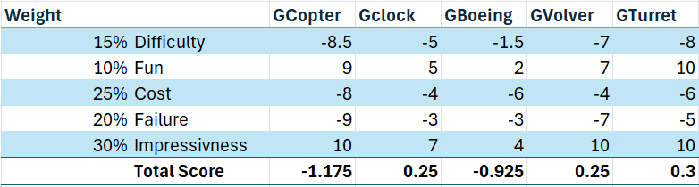To facilitate selection, applications were ranked (*Table 1*.) according to five different criterias: The potential difficulty of the project, how “fun” the project would be to do, the likely total cost, the expected failure rate and the “impressiveness” of the project. The total score of each application was calculated considering the different weight of each category.

*Table 1. Each applications ranked by different criterias.*

*-10 to 10, 10 being the best.*

During Bjarne’s morning classes, we observed an increase in drowsy students, which is likely to cause a drop in students grades. To avoid this potential drop, we have decided to attempt to reduce the number of drowsy students. In the following paragraphs, we’ll explore the different requirements, the available technologies and the technicalities amongst different criteria.

# Key Criterias

1. Design a DC brushed motor to be a servo motor.
   1. Including such a motor was a requirement by the semester project professors.
2. Maximum of 24V.
   1. We decided on using a 12V battery because of two main reasons.
      1. 12V is a common voltage intake for most components on the market, facilitating voltage step downs.
      2. Using components that we already have access to will reduces our expenses.
3. Nextion Display for input and output purposes.
4. Precise rotation in both the x-axis and y-axis.
   1. The precision is to be dictated by the angle needed to accurately splash the area of half a two person table (such that it can splash the work area of 1 student). From there we can calculate the minimum and maximum angles to find the precision needed.
   2. Targeting done via a grid system (resembling a chessboard) to fit the classroom fixed rectangular structure and therefore predetermined positions.
5. The turret needs to be able to shoot any seats in the classroom 102, which is three rows and approximately G meters.

# Other Specifications

* For power access, a USB-C will be used to recharge the battery.
* Because of the carry weight limit the Bjarne has at work the maximum weight is 11 kilograms.1
* Usage of both USB-C and battery, where the battery acts as the same power source for the turret.

# Parts

## A screenshot of a computer AI-generated content may be incorrect.Micro Controllers

*Table 2. Ranking of the different Micro Controllers based off different criterias;*

*1-10, 10 being the best.*

Parts were ranked (*Table 2.)* based on their logic level, ease of implementation (i.e. how easy we could install and program them), price, and raw performance (i.e. physical computing limitations). The Arduino/Seeeduino is a polyvalent open-source microcontroller. The ESP-32 and Pi are similar platforms running on a different logical level, with additional features such as Wi-Fi or Bluetooth.

The Seeduino appears as the best contender, due to its wide availability and low price. Moreover, our previous experience with it will prove valuable when implementing it in our project.

1 https://at.dk/regler/at-vejledninger/loeft-traek-skub-d-3-1/

## Measurements device for the targeting system

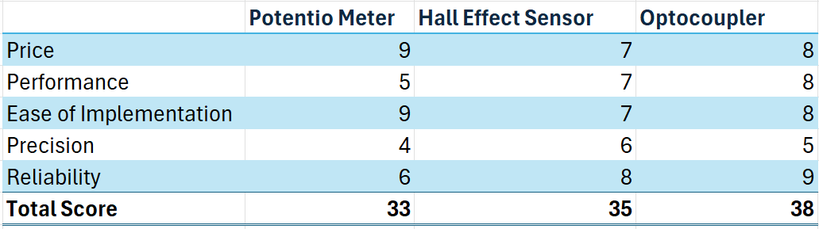

**Potentiometer**: very affordable and easy to implement but lacks precision and long- term reliability due to mechanical wear.

*Table 3. Ranking of the different Measurement devices for the targeting system, based off different criterias;*

*1-10, 10 being the best.*

**Hall Effect Sensor**: Moderately priced with good performance and precision, suitable for non-contact sensing, offering high reliability.

**Optocoupler**: Reliable for isolating signals with good ease of implementation, but precision is limited by switching characteristics.

### Ranking Categories

1. *Performance:* We wish our technology to be able to quickly react to inputs so we can make our turret faster.
2. *Ease of Implementation:* The faster we can implement, the faster we can finish our prototypes and have more time to troubleshoot.
3. *Precision:* We want to avoid splashing students who are not asleep. Precision dictates the angle the turret splashes in and the larger the distance, the more the error propagates.
4. *Price*: an important criteria because we will need to implement the technology at least twice to account for both axis. We also wish to go under the budget such that we have a safety net in case something fails to be able to replace it.
5. *Reliability*: We do not want to get Bjarne mad from having to repair it often. He might splash us. We want to make our technology last as long as possible before needing repairs.

The optocoupler appears as a clear winner. It has the highest overall score and, therefore, has been decided to be the chosen technology.2

2 The optocoupler performs the best because the holes are rigid and unchanging. The only thing that brings it down is our experience with programming it. Moreover, the reliability of the optocoupler is high because the amount of holes is not expected to change and therefore, the angles are also not expected to alter much when being tested. However, we do not expect the precision of the optocoupler to perform up to our very rigid standards because its inability to account for the angles in between the holes.

# Hard Goals

1. Water cannon minimum (required) reach of G meters.
   1. This is the largest distance from the desk of the teacher (where the turret is located) to the furthest table in the U105 classroom.
2. Turret should change angle/target in maximum time span of 30 seconds. This time span was chosen in accordance with the students’ reduced reaction time induced by their sleepiness.
3. Usage of a system to allow Bjarne to select where the turret should aim and shoot.

# Soft Goals

1. Manual targeting system display exact degrees for Bjarne to teach the next generation about Dynamics/Mathematics.
2. *The Nextion display* will act as the interface for our turret. In order for Bjarne to select the students

to wake up, we have devised two targeting acquisition methods.

1. *Fixed selection grid**.3*
   1. In this method we have a grid, much like a chess board with the x and y coordinates. This ensures that we don't require much precision in the actual turret, because of the turret being rather big, it would be almost impossible not to have a bit off.
   2. The grid would be a 2D representation of the class, where the class is first divided into four quarters on the screen, and each of those quarters have 3 rows and as many rectangles (i.e. tables) as the screen can display.
2. Manual Input Mode.
   1. In this method, the X and Y coordinates can be chosen, giving Bjarne the possibility to manually input take control of the turret to target students that may have unusual sleeping patterns, such as floor-sleepers.
   2. A joysticks/button setup would be used to manually take control of the turret.
3. Limitations of collateral splashes.
   1. The turret should be accurate, and collateral splash should be as limited as possible. However, a certain amount of collateral splashing can be regarded as tolerable given the physical limitations of the turret setup and chemical properties of the liquid employed in the turret.

3 The Fixed Selection Grid Targeting System (i.e. Automatic Mode) is tailored made to be working in class 105 specifically because of its advantageous dimensions.

### Sketches of the potential Design

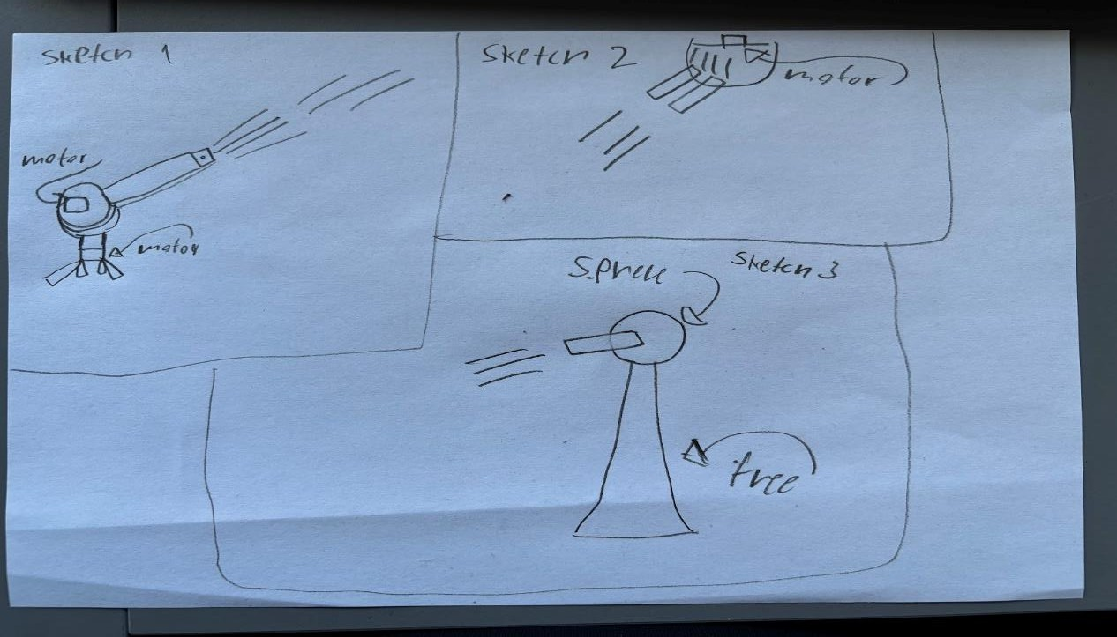

*Sketch 1-c.*

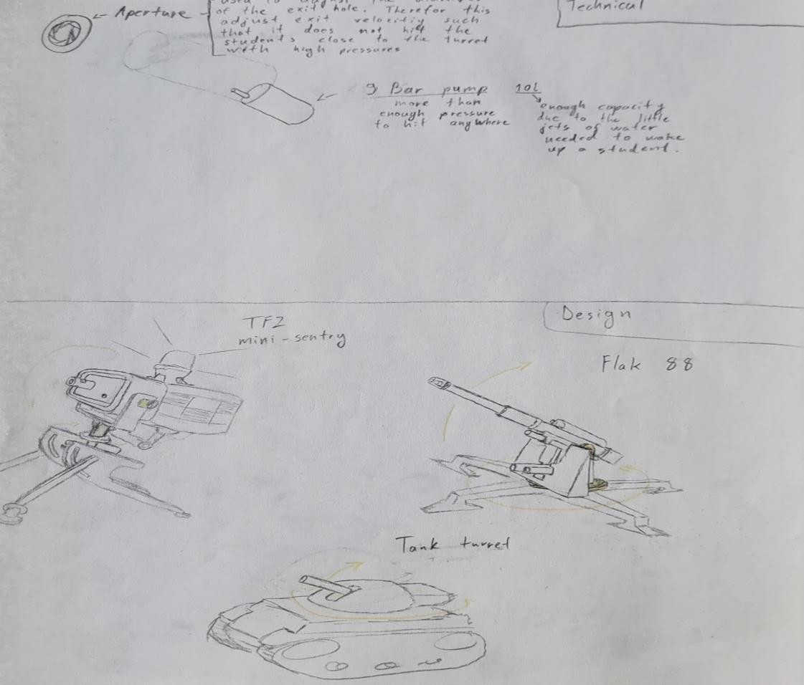

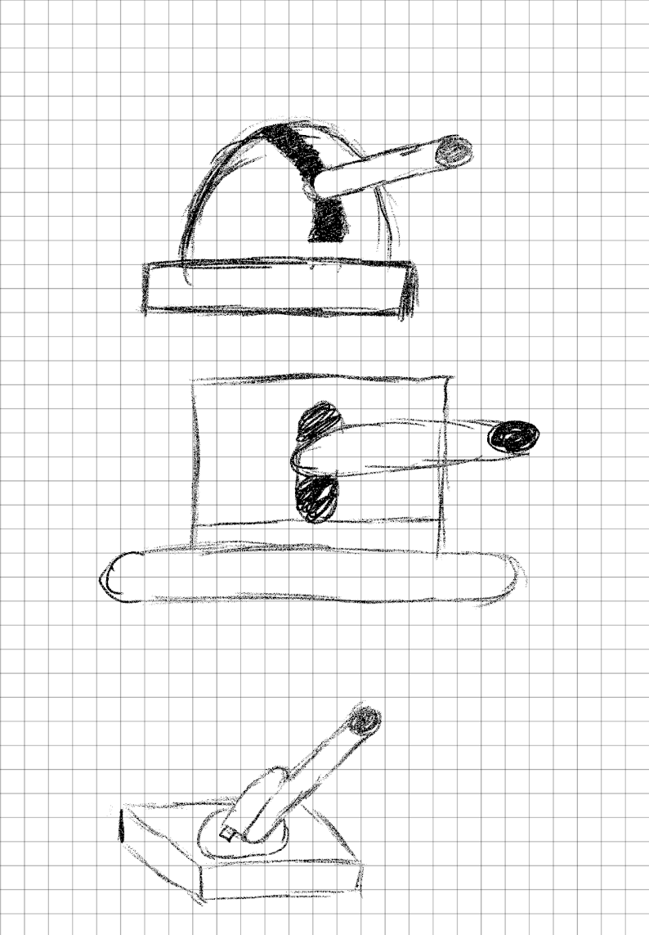 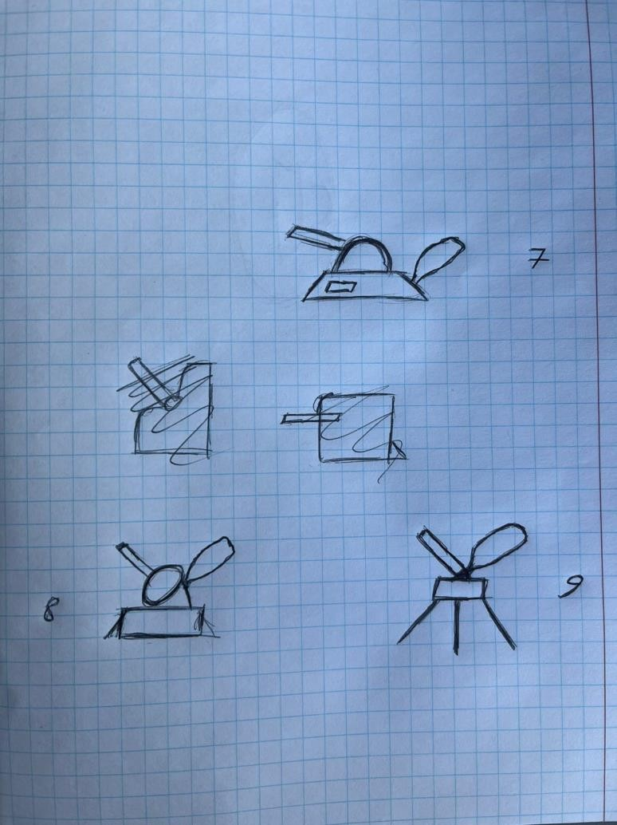

*Sketch 3-c. Sketch 4-c.*

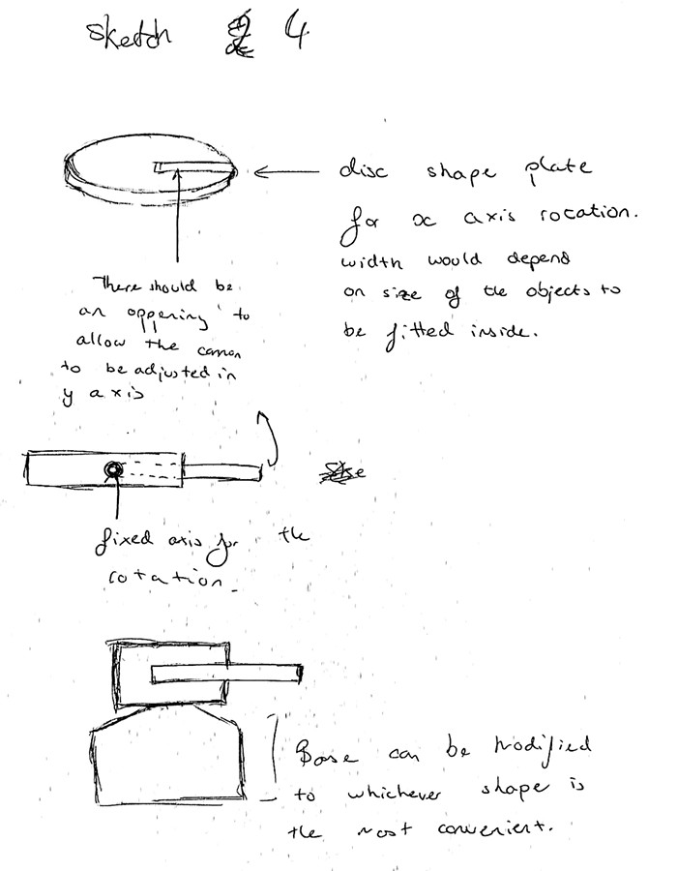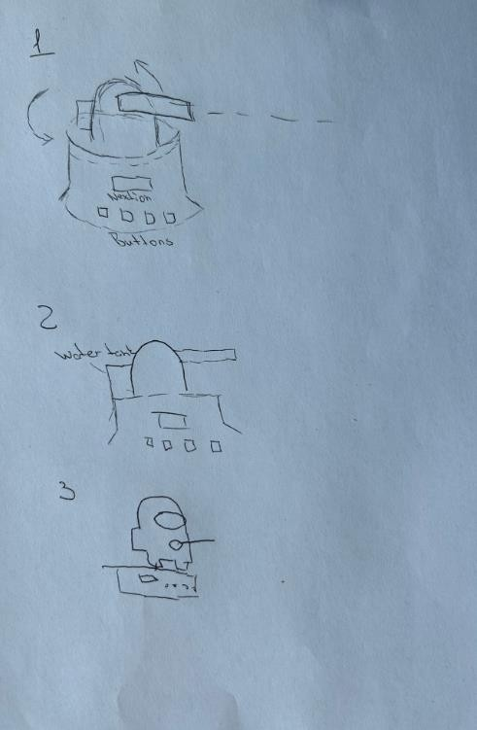

*Sketch 5-c. Sketch c-c.*

II. Modelling